TIME | EMBASSY | REGENCY | CAMELIA | MARYLAND | WAYNE |  | TERRACE
7:00 – 7:30  Exhibitors Only |  | MEGA MARYLAND |  |  |  |  | Exhibitor  Set Up
7:30 - 8:30  Registration | Breakfast & Networking |  |  |  |  |  | Coffee & Networking
8:30 - 9:00 | CONFERENCE WELCOME  Master of Ceremonies,  LTC Geoffrey Kuhlmann,  Deputy Commander,  USACE Baltimore | 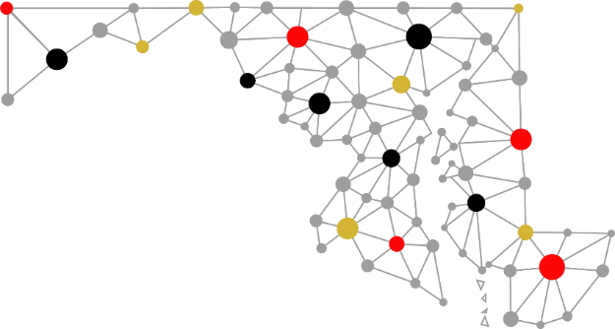 |  |  |  |  | Exhibit Hall Closed
9:00 - 10:00 | MORNING KEYNOTE | Jonathan Murray, WBAL Radio Financial Contributor and Wealth Management Specialist, UBS Financial  Jonathan will address current economic conditions, investment themes, and wealth management strategies for individuals and firms and how we can best prepare for future changes in the market and the impact on design and construction projects.
10:00 - 10:10 | MOVE TO BREAKOUT SESSIONS
10:10 - 11:00 |  | Military Installation  & Federal Agency Opportunities  Hear from Agency and Military Installation officials about current initiatives and upcoming opportunities on their campuses and facilities.  Bill Burris,  JB Andrews/AFCEC  Jimmy Patel,  JHU Applied Physics Lab  Dwight Deneal,  US Coast Guard  Scott Jackson, NSA  Cynthia Mason-Posey,  Veterans Affairs | Transportation Design-Build +  P3 Opportunities  MDOT experts will discuss Maryland’s  I-270/495 P3 Project and MD SHA will address the  I-270 Congestion Management project. Opportunity Maryland will give insight and tips how small and disadvantaged firms can participate on P3 and design-build projects in the State of Maryland.  Sean Campion,  MD SHA, Innovative Contracting  Joe Lewis, Opportunity MDOT | Cyber  Security  Learn how companies can protect their assets. A case study on City of Baltimore Malware issue and lessons learned will be presented.  Tim Schibach, Penacity LLC | Energy  STATE: Learn about statewide energy initiatives and the new technology that will impact future design and construction projects.  Lauren Buckler, Assistant Secretary,  MD DGS  FEDERAL: Getting All Systems A-Go: Improving DoD Critical Systems & Integrated Commissioning Processes - with the NAVFAC, USACE and other DoD agencies.  Dylan Desimone,  Sr. Project Manager, GHD  Matthew Polley,  Fire Protection & Life Safety Engineer, GHD |  | Exhibits & Networking
11:00 - 11:30 | COFFEE BREAK & NETWORKING IN EXHIBIT HALL (TERRACE)
TIME | EMBASSY | REGENCY | CAMELIA | MARYLAND | WAYNE |  | TERRACE
11:30 - 12:20 |  | Federal Small Business Programs  Interested in getting on the GSA Schedule? Or forming a Mentor-Protégé relationship? Or find out what exactly an 8(a) or HubZone is?  This is the session for you!  Kevin Pope,  Small Business Technical Advisor, GSA  Denise Benjamin-Sirmons,  Director, OSDBU, US EPA  Dennis Smith, Project Director, Minority Business Development Center – Capital District | Economic Development in Maryland  Opportunities are abound in the State of Maryland! Get the scoop on projects that are about to hit the street and future development projects in the State.  Gary Hodge,  President  Regional Policy Advisors  Robert McCord, Secretary of Planning, State of Maryland  Frank Dickson,  Maryland Opportunity Zones  Steve Preston,  Parks & People | Maryland School Construction  A look into the Kirwan Commission’s findings and the Governor Hogan’s proposed $3 billion school investment and the future of school construction.  Senator  Bill Ferguson,  46th District  Shawn Matlock, PGCPS  Gary McGuigan  MSA/Baltimore City 21st Century Schools | State Procurement & Partnering  An update on the Statewide Procurement Modernization and a primer on how to best do business with the State.  Tracie Watkins-Rhodes, Director,  MDOT Office of Small and Minority Business Policy |  | Exhibits & Networking
12:20 - 12:30 | GRAB A SEAT FOR LUNCH!
12:30 – 1:30 | LUNCH  KEYNOTE | DJ Gribbin, Futurist, Founder of Madrus, LLC and Former White House Special Assistant on Infrastructure  DJ will address the current state of the nation’s infrastructure, permitting reform and the new technologies and innovations that will impact future projects across the region and the Country. |  |  |  | Exhibit Hall Closed
1:30 – 2:00 | DESSERT & COFFEE IN THE EXHIBIT HALL (TERRACE)
2:00 – 3:00 | Agency Panels: Lessons to Win Work & Build Client Relationships
 | Federal Panel  NIH  EPA  GSA  USACE, Baltimore  MBDA  VA | State Panel  DGS  GOMA  MDOT  MDOT SHA  Opportunity MDOT |  |  |  |  | Exhibits & Networking
3:00 – 3:10 | MOVE TO ROUNDTABLE DISCUSSIONS
3:10 – 4:30 | Agency Roundtable Discussions
3 – 20 minute sessions w/ 5 minutes between each to move to another table | Participating Roundtable Agency Hosts | USACE Baltimore District  National Institutes of Health  General Services Administration  Environmental Protection Agency  MDOT Office of Small & Minority Business Policy  MD Department of General Services  Governor’s Office of Small, Minority & Women Business Affairs  Veterans Affairs  JB Andrews/AFCEC  MD State Highway Administration  Opportunity MDOT  Minority Business Development Agency (MBDA) – Capital District Business Center |  |  |  |  | Exhibitor Breakdown  & Move Out

